**Game concept**

It’s casual, 2D, “Frogger” style, where the player controls a dragon who needs to reach a treasure and avoid valkires.

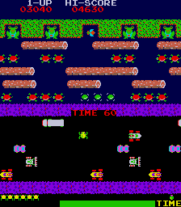

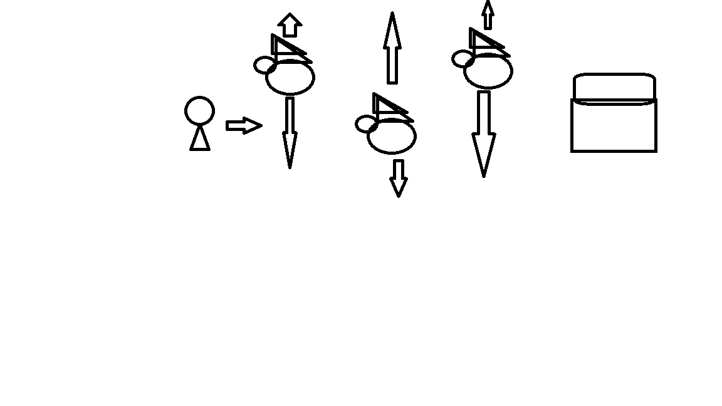

* **Up and down movement on the player**

**Target Platforms**

* Desktop
* Browser

**UI/Player Controls**

* WASD
* When the player clicks a key its moves in that direction

**Game Mechanics**

* Valkyries moving up and down (bouncing movement)
* If the player is hit by a valkyries, the game restarts
* The player wins if they reach the treasure. The game will restart
* Play moves in one direction

**Assets**

* Style: Pixel art, 8-bit style, retro RPG
* 8 bit background music
* Sprites:
  + Background
  + Player
  + Enemy
  + Treasure